Free design help 

-remover book appoiment.

3-Day Quick Ship Guarantee

Free Kitchen Design Services

Lowest price guarantee

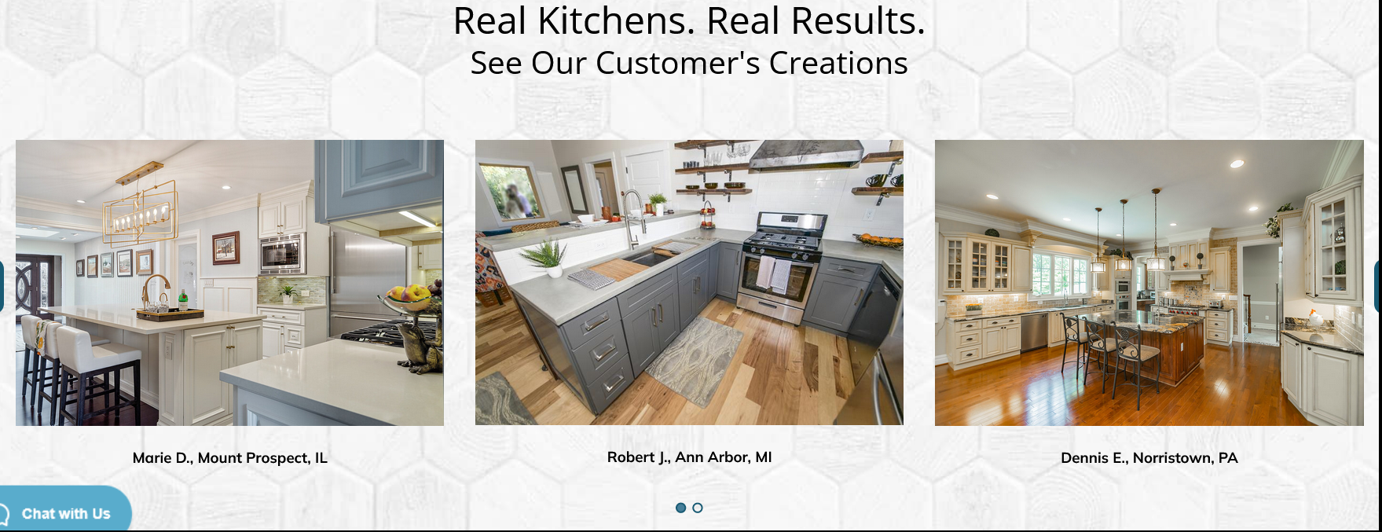

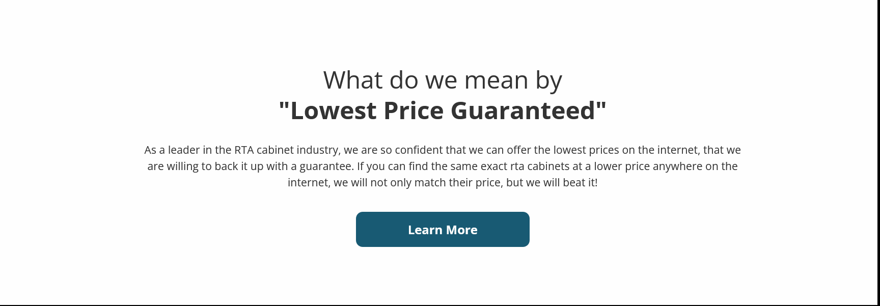

As pioneers in the RTA cabinet realm, we stand boldly behind our commitment to offer the most competitive prices online. We're so confident in our pricing that we offer a guarantee: should you discover identical RTA cabinets at a lower price elsewhere on the internet, we won't just match their price, we'll surpass it!

Contacts us Info:

8000 s orange ave

Orlando, FL 32837

United States

4076249153 – Customer Service

Shipping and return policy:

**Ordering Policies**

* By using fourcornerskitchens.com, you are responsible for maintaining the confidentiality of your account and password, and you agree to accept all responsibility for all activities that occur under your account. All orders placed on fourcornerskitchens.com website must be made by persons 18 years of age or older. You agree that all information that is entered into the system is true to the best of your knowledge. fourcornerskitchens.com reserves the right to refuse service, remove or edit content, terminate accounts, or cancel orders at its sole discretion.
* Customers are responsible for ensuring the accuracy of all orders.
* Accuracy of the shipping information is the sole responsibility of the customer. Customers will incur any additional costs or fees associated with errors in shipping information.
* All orders must be paid in full in order to be processed.
* **Orders cancelled are subject to 20% restocking fee.**

**General Shipping Policies**

* fourcornerskitchens.com uses third-party freight carriers and parcel delivery services. Carriers assume responsibility of the orders while in transit.
* Orders will process and ship within 5-15 business days (Monday thru Friday), but can sometimes ship sooner.
* **Processing time does not include transit time**.
* fourcornerskitchens.com does not guarantee delivery dates and is neither liable nor responsible for unforeseen circumstances beyond its control, so please allow for potential delays in transit time or other delays caused by supply chain disruptions.
* The website generated shipping quote is not guaranteed, and fourcornerskitchens.com reserves the right to modify shipping estimates at our discretion to account for changes in rates or fuel costs.

In addition to our regular ordering and shipping policies, we have some policies that apply to our assembled cabinet orders (all other ordering, shipping, and receiving terms and policies apply)…

### ****Tractor Trailer Accessibility****

* If your delivery address is not accessible by a 53’ tractor trailer, a “straight truck” is required to deliver to your location. In this case, depending on the weight of your items, a lift-gate may be required to off-load your order from the truck.
* A lift-gate is a device used to raise and lower items from ground level to the level of a tractor trailer. Freight companies deliver items on a tractor trailer which is approximately 56 inches above the ground. These trailers are designed to load and unload at a loading dock or with a fork-lift.
* Straight truck delivery is delivery on a smaller truck than a regular 53’ tractor trailer. A straight truck would be required for residences that may be on a dirt road, dead end street or any location where a tractor trailer would not be able to easily deliver to the curb.
* Not all trucking terminals have a straight truck available for delivery. We do not know which destination terminal the shipment will arrive at, so we are unable to anticipate which terminals have straight trucks available. If a straight truck is not available for your delivery address, you will have the option to meet the driver at a location where they can pull the large truck into and offload the cabinets (such as a parking lot) or you would have to go to the destination terminal of the trucking company to obtain your shipment.

### ****Receiving Policies****

* Once a shipment arrives at the final-destination terminal, the third-party carrier will contact the customer to schedule a delivery. Failure to establish a delivery appointment with the carrier will result in the carrier charging storage fees until such time as the delivery can be made.
* Customers are solely responsible for any/all storage fees incurred. (Local pick-ups at the fourcornerskitchens.com physical location will incur a $35/day storage fee if not picked-up by the customer within 10 business days).
* Customer (or authorized representative) must be present to accept delivery and must be 18 years of age or older.
* Residential delivery is defined as **CURBSIDE DELIVERY**.
* Unless otherwise stipulated (as with assembled cabinet orders), deliveries will **NOT** be brought into a customer’s home. Customer is responsible for transporting items from the street into the property.
* In certain instances, assisting the freight carrier’s driver with some off-loading from the truck may be necessary.
* Customer must inspect order for visible damages or missing items while the driver is present.
* All damages and/or missing items must be noted on the delivery receipt/bill of lading **while the driver is present**.
* Paperwork must include signatures of both the customer and the driver. Customers have the right to demand the driver waits until an inspection for visible damages is complete.
* **Customers should accept orders with visible shipping damages** after noting the damages on the delivery paperwork. Doing so will facilitate the claims process and enable fourcornerskitchens.com to replace the damaged items more quickly.
* Bills of lading include the number of cartons which may not coincide with the number of items on the order as some items are packaged together. You must check that all items on the order have been received before signing the paperwork.
* fourcornerskitchens.com will not be held responsible for missing items not noted on the delivery paperwork at the time of delivery.
* **All vanity/counter tops must be opened and inspected for damages while the driver is present**. Failure to do so will result in such claims being denied.
* Unlike cabinetry & accessory orders, **if a vanity/countertop is found to be damaged during shipping, customer must refuse to accept delivery**.
* **Concealed damages and missing items must be reported within 48 hours.** Customer is responsible to open and inspect the entire order within 48 hours or any claims for concealed damages or missing items may be denied.

### ****Return Policies****

* Customers are encouraged to call fourcornerskitchens.com Customer Service to start the return process.
* Customers must file a return authorization request by either logging into their fourcornerskitchens.com account under which the item(s) were ordered and following the steps laid out on the site to process the return or do so by accessing their order if they checked out as a guest.
* All returns must be processed by the customer within 30 days of product receipt. **Any returns processed by the customer after 30 days will be issued store credit** (less costs and fees where applicable).
* Only items that are properly packaged in the original box will be accepted as a return.
* After receiving and inspecting returned items, fourcornerskitchens.com reserves the right to reject any return if items are not in the proper condition.
* Customers are responsible for the cost of the return shipping.
* **Returned items are subject to a 20% restocking fee.**
* Refunds (less costs and fees where applicable) will be issued within 30 days of return receipt and inspection of the items.
* Assembled cabinet orders are not able to be returned. Please refer to the [Assembled Cabinet Policies](https://www.rtacabinetstore.com/shipping-returns/#assembled)
* **Returned Accessories, defined as any product from our 'Accessories' section(s) throughout the website; are subject to a 50% re-stocking fee**

### ****Claims Policies****

* After a customer has documented any damages on the delivery paperwork as noted in the Receiving Policies, it is necessary to go to fourcornerskitchens.com and click on the [*file a claim link*](https://www.rtacabinetstore.com/order-management/user-claims-form) at the bottom of our homepage to provide the necessary documentation of the damages.
* Concealed damages and missing items must be reported within 48 hours. Customer is responsible to open and inspect the entire order within 48 hours or any claims for concealed damages may be denied.
* The following information is required to properly file a claim:
  + Order number
  + Copy of signed delivery paperwork notating damages (if visible upon receipt)
  + Photographs of damages (concealed or otherwise)
  + Photos must be of the entire part/panel with damage visible (no close-ups necessary)
  + **Photos must be in .jpeg file format**
  + List of damaged items with description of damages
* It can take between 7 - 10 business days before your replacement parts are shipped.
* Replacement parts will not be sent out if the cabinets/vanities are already assembled and/or installed with the exception of doors. If you discover damage after assembly or installation of the product(s), your claim will not be honored/denied. If you have glued, pinned, stapled, or altered the product in any way & are unable to detach the damaged part or piece, we will not replace the entire cabinet.
* This warranty does not cover damage resulting from accidents during assembly, misuse, dirt, water, tampering, un-reasonable use, improper installation, servicing performed or attempted by unauthorized service agencies or units that have been modified or used for commercial purposes.

**\*\*\*** fourcornerskitchens.com **reserves the right to change its assembled shipping policies and requirements at any time prior to purchase.**

### ****Disclaimers****

**Website Imagery Disclaimer:** Customers are strongly encouraged to order a sample to ensure the color, finish, and style is exactly what the customer wishes to order. fourcornerskitchens.com is not responsible for items ordered based solely on the imagery on our website and reserves the right to reject a return or a claim based on dissatisfaction with color, finish, or style if a customer fails to order a sample prior to placing their main product order.

**Natural Wood Disclaimer**: Variations in color, grain, and other growth phenomena are a natural characteristic of wood. Changes in color on finished wood can occur due to exposure to light and other environmental factors. These variations and color changes are not deemed defective and therefore are not covered in the claims process or under our warranty

**Finishes/Glazes/Distressing Disclaimer:** Variations in our cabinetry's hand applied finishes and glazes are not considered to be defects in material or workmanship.

The stain and paint that we sell has been expertly matched by Sherwin Williams to match the finish on your cabinets. It is intended for touchups. fourcornerskitchens.com is not responsible for touch-up paint that is used on unfinished wood or anything other than touch-up as the finished product may not be an exact match. Wood species, grain, and porousness can contribute to the failure of finishes matching. fourcornerskitchens.com will provide the matching Sherwin Williams formula to one of our cabinet finishes if requested. However, it is not responsible for the accuracy of the mixture that Sherwin Williams provides.

**Changes to Finishes or Product Design Disclaimer:** fourcornerskitchens.com may modify product due to supplier availability and as changes or improvements are implemented but is under no obligation to make these changes to previously manufactured product. If a warranty claim is filed after a product or finish becomes obsolete or is discontinued, fourcornerskitchens.com reserves the right to honor the warranty in the following ways:

* To replace the affected component with a new component of the same style if available.
* To replace the affected component with any other component(s) to achieve a similar appearance with a style that is comparable in appearance, color, design or construction based upon current product offerings.

<https://www.rtacabinetstore.com/>

colocar logo a la izquierda del footer y quitar qukick shop

Menu footer:

**Informations:**

-About us

-login

- shipping and police

-privacy policy (https://www.rtacabinetstore.com/privacy-notice)

-customer services:

- FAQS

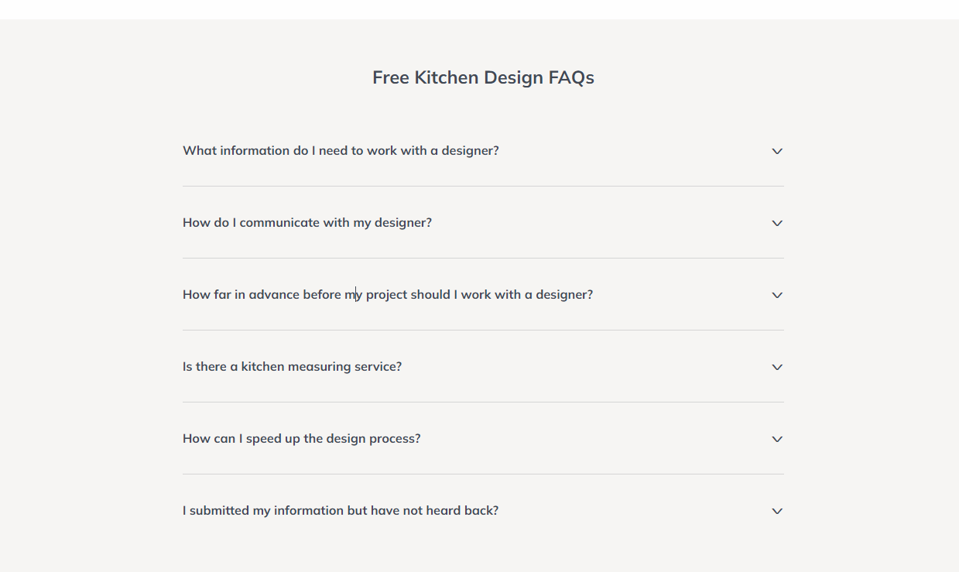

- Contact us

https://www.rtacabinetstore.com/assets/html/free-kitchen-design/

